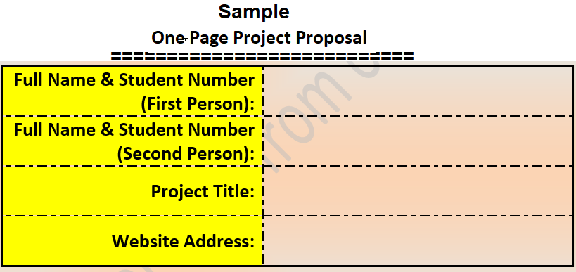

**Jaswinder Kaur (811730)**

**India’s Transportation System**

**Mandeep Kaur (813435)**

**https://github.com/JasMan101/JasMan101**

Description:

We are going to make a webpage and presentation with some interactive activities on transportation system in India. In this project we will analyze and explain in India, how different kinds of transport facilities are provided by different provinces. Our project is going to include means of transport like metros, cars, buses, and many other things. We are also going to give an overview of how modes of transportation vary in different provinces, like how some provinces have a metro facility which connects all the areas whereas some provinces just have buses which are used as means of transportation. As India is a very large and diverse country so are project is going to show diversity in modes of transportation in India.

In this project, we will perform the following tasks:

1. We are going to investigate different kind of modes of transportation used in India and how they vary according to the need of people.
2. We are going to discuss how new emerging modes of transportation are introduced by the government, and their effects on public lifestyle.
3. We will compare different types of transportation used in different areas according to their daily needs.

A webpage will be made using HTML and JAVASCRIPT. We will be working together on it, in which presentation, sources and necessary information will be gathered by Mandeep Kaur (813435) and coding will be performed by Jaswinder Kaur (811730).

We will make our project using the functions given below:

1. Multiple iframes
2. Conditional Statements (if-else statements)
3. Loops
4. Functions
5. Arrays
6. URL links
7. Images
8. Objects
9. Multimedia features

We will demonstrate our knowledge and skills we have learned in this course like HTML tags like div, section, a, p, text area and many more.

We will collect the required information by March18 individually, and we will combine tasks we performed by ourselves and will complete our programming and presentation by March 22. In this way, we are hoping for our project to be done by March 25.

In this project CSS tags will also be used along will JAVASCRIPT and various interesting kinds of animations and graphics will be added to our project.